BORDERWATCH
Section 1 - Infrastructure Setup
High-Availability Goods-in-Transit Surveillance System
Project | Section | Deployment Model | Evidence
BorderWatch distributed customs surveillance | Infrastructure Setup (15 marks) | VPS-ready Docker Compose stack | docker-compose.yml, Dockerfiles, Nginx, scripts, monitoring configs

Assessment focus: This section documents the real infrastructure implemented in the project repository: containerized Spring Boot services, a React frontend served through Nginx, RabbitMQ messaging, MySQL persistence, Prometheus/Grafana monitoring, and Bash automation scripts. Terraform and Kubernetes are optional extensions; the current project deploys through Docker Compose.

1. Infrastructure Objective
BorderWatch requires an infrastructure capable of receiving GPS telemetry from truck beacons, routing API traffic to the correct backend service, detecting corridor deviations, recording compliance violations, and exposing monitoring data for operations. The implemented environment is designed for local demonstration and VPS deployment using the same Docker Compose topology.
- Provision a Linux host or on-premise server with Docker Engine and Docker Compose.
- Run three Spring Boot microservices with two replicas each for ingestion, tracking, and compliance.
- Expose a single public HTTP entry point through Nginx while keeping internal services on the Docker bridge network.
- Use RabbitMQ for asynchronous telemetry and violation event delivery.
- Use MySQL 8 for users, trucks, telemetry, violations, audit chain, notifications, and seed data.
- Provide operational visibility through Prometheus, Grafana, Alertmanager, and node-exporter.

2. Provisioned Resources
Resource | Implemented choice | Project evidence | Purpose
Compute host | Linux/VPS-ready host | scripts/start.sh, docker-compose.yml | Runs the complete BorderWatch stack from one command.
Container runtime | Docker + Docker Compose | docker-compose.yml | Builds and orchestrates 13 service containers.
Application gateway | Nginx 1.27 Alpine | gateway/Dockerfile, gateway/nginx.conf | Serves React assets and reverse-proxies API traffic.
Database | MySQL 8.0 | scripts/schema.sql, scripts/seed.sql | Stores operational data and seeded demo users/trucks.
Message broker | RabbitMQ 3.13 management image | docker-compose.yml, RabbitMqConfig.java | Decouples telemetry ingestion from tracking and compliance.
Monitoring | Prometheus, Grafana, Alertmanager, node-exporter | monitoring/* | Collects service metrics and infrastructure health signals.

3. Container Topology
The Docker Compose file defines a bridge network named bw-net and persistent volumes for MySQL, RabbitMQ, Prometheus, and Grafana. Application services are built from project Dockerfiles and are exposed internally to Nginx, not directly to the public network.
Service group | Replicas | Internal port | Main responsibility
ingestion-service | 2 | 8081 | Authentication, user/truck APIs, telemetry ingestion.
tracking-engine | 2 | 8082 | Geofence analysis and OFF_ROUTE event generation.
compliance-service | 2 | 8083 | Violation persistence, penalty classification, audit chain API.
gateway | 1 | 80 | React SPA hosting, reverse proxy, API rate limiting.
mysql | 1 | 3306 | Relational persistence and seed data loading.
rabbitmq | 1 | 5672 / 15672 | AMQP queues and management UI.
prometheus/grafana/alertmanager/node-exporter | 4 | 9090 / 3000 / 9093 / 9100 | Monitoring and alerting stack.

4. Infrastructure Diagram
The diagram below summarizes the implemented deployment path from users and GPS beacons through the reverse proxy, backend services, broker, database, and monitoring layer.
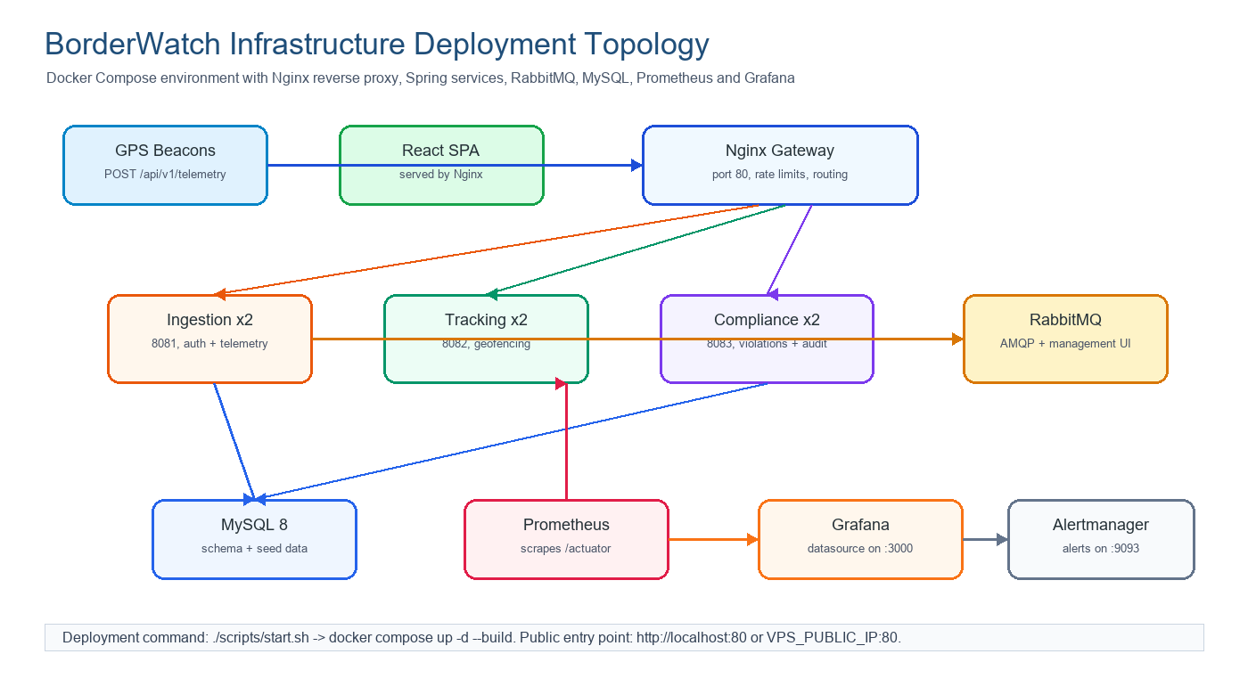
Figure 1. BorderWatch Docker Compose infrastructure topology.

5. Networking, Firewall and Reverse Proxy
Networking is handled in layers. Docker Compose isolates backend containers on bw-net, Nginx provides the single application ingress point, and host/VPS firewall rules should expose only the ports required for users, administrators, and monitoring.
Port | Service | Exposure | Reason
80 | Nginx gateway | Public | Main entry point for React SPA and /api/v1 routes.
3000 | Grafana | Admin only | Dashboard access; should be restricted on a real VPS.
9090 | Prometheus | Admin only | Metrics query UI; should not be public in production.
9093 | Alertmanager | Admin only | Alert routing UI; should be restricted.
15672 | RabbitMQ management | Admin only | Broker management; never expose broadly.
13306 | MySQL host mapping | Local/dev only | External database access for development; close on production VPS.
22 | SSH | Admin only | VPS administration; restrict by source IP.

Recommended VPS firewall commands:
sudo ufw default deny incoming
sudo ufw default allow outgoing
sudo ufw allow 22/tcp
sudo ufw allow 80/tcp
sudo ufw allow 443/tcp # if TLS is enabled with a certificate
sudo ufw allow from <ADMIN_IP> to any port 3000,9090,9093,15672 proto tcp
sudo ufw enable

6. Reverse Proxy Routing
The Nginx gateway uses least-connection upstreams for the replicated Spring services and applies separate request limits for authentication and telemetry traffic. React assets are served from /usr/share/nginx/html, while API paths are routed to the correct internal service.
Route | Upstream | Configuration evidence
/api/v1/auth | ingestion-1/ingestion-2:8081 | gateway/nginx.conf rate-limits auth at 10 r/s.
/api/v1/telemetry | ingestion-1/ingestion-2:8081 | gateway/nginx.conf allows higher telemetry burst capacity.
/api/v1/trucks, /api/v1/users | ingestion service | Routes registry and user APIs to ingestion.
/api/v1/tracking | tracking-1/tracking-2:8082 | Routes geofence analysis to tracking engine.
/api/v1/compliance | compliance-1/compliance-2:8083 | Routes violations, stats, and chain APIs to compliance.
/ | React SPA | Nginx try_files fallback supports client-side routing.

7. Installed Technologies
Layer | Technology | Installed/configured through
Frontend | React 18, TypeScript, Vite, Zustand, React-Leaflet, Recharts | frontend-react/package.json and gateway Dockerfile.
Backend | Java 21, Spring Boot 3.3, Spring Web, Security, JPA, AMQP, Actuator | Three Maven POM files and service Dockerfiles.
Messaging | RabbitMQ 3.13 Management | docker-compose.yml and RabbitMqConfig classes.
Database | MySQL 8.0 | docker-compose.yml, scripts/schema.sql, scripts/seed.sql.
Gateway | Nginx 1.27 Alpine | gateway/Dockerfile and gateway/nginx.conf.
Observability | Prometheus, Grafana, Alertmanager, node-exporter | monitoring directory and compose services.
Automation | Bash scripts and Jenkinsfile | scripts/start.sh, stop.sh, run-tests.sh, chaos_monkey.sh, Jenkinsfile.

8. Deployment Automation Scripts
The project uses Bash automation rather than Terraform. The scripts are simple, auditable, and sufficient for a VPS or lab machine where Docker is already installed.
Script | Function | How it supports infrastructure marks
scripts/start.sh | Builds and starts all containers with docker compose up -d --build. | Demonstrates repeatable environment setup.
scripts/stop.sh | Stops the stack with docker compose down. | Provides controlled shutdown.
scripts/run-tests.sh | Runs Maven tests for the three Spring services. | Supports validation before deployment.
scripts/chaos_monkey.sh | Kills selected containers and measures recovery time. | Demonstrates resilience and self-healing behavior.
scripts/schema.sql / seed.sql | Creates database schema and demo data. | Automates database provisioning.

Core deployment sequence:
cp .env.example .env
# edit .env: MYSQL_ROOT_PASSWORD, MYSQL_PASSWORD, RABBITMQ_PASSWORD, JWT_SECRET, GRAFANA_PASSWORD
./scripts/start.sh
docker compose ps
curl http://localhost/health

9. Monitoring and Health Checks
Each Spring service exposes health and Prometheus endpoints through Spring Actuator. Docker Compose uses health checks before allowing dependent services such as Nginx to start. Prometheus scrapes ingestion, tracking, compliance, and node-exporter targets.
Monitoring item | Implemented configuration | Purpose
Spring Actuator | health,prometheus,info endpoints | Service liveness and metrics export.
Prometheus scrape jobs | ingestion, tracking, compliance, node-exporter | Central metrics collection.
Alert rules | ServiceDown, HighCPU, LowMemory | Operational alerting for outages and resource pressure.
Grafana datasource | Prometheus provisioned as default | Dashboard-ready monitoring datasource.
Docker health checks | wget /actuator/health for each service | Container readiness and dependency ordering.

10. Deployment Evidence Links and Screenshots
The following URLs are the expected evidence points after running ./scripts/start.sh on a lab machine or VPS. These are the screenshots that should be captured for submission.
Evidence screenshot | URL or command | Expected result
Frontend SPA | http://localhost:80 | BorderWatch login page and dashboard after login.
Gateway health | http://localhost/health | {"status":"ok"} response.
Grafana | http://localhost:3000 | Grafana login with Prometheus datasource configured.
Prometheus targets | http://localhost:9090/targets | ingestion, tracking, compliance and node-exporter targets UP.
RabbitMQ management | http://localhost:15672 | RabbitMQ management console for queues/exchange.
Container status | docker compose ps | All application containers running/healthy.
Smoke telemetry | python simulator/simulator.py --rps 100 --duration 10 | Accepted telemetry requests and P95 latency output.

11. Security Notes and Production Hardening
Important: The repository currently supports a demonstration deployment. For production, rotate all .env secrets, restrict admin ports by source IP or VPN, add TLS on port 443, validate each GPS beacon API key against trucks.api_key_hash, and remove public demo credentials.

- Keep only Nginx public; do not expose Spring service ports directly.
- Restrict Grafana, Prometheus, Alertmanager, RabbitMQ management, and MySQL to administrators.
- Replace default JWT, MySQL, RabbitMQ, and Grafana secrets before deployment.
- Use HTTPS with Let's Encrypt or another certificate authority for browser and beacon traffic.
- Add backup policy for MySQL volume and RabbitMQ state if deployed beyond a classroom demo.

12. Marking Summary
Requirement | How BorderWatch satisfies it
Provision cloud/on-premise resources | The stack is VPS-ready and deploys on a Docker-capable Linux host using docker-compose.yml.
Install necessary technologies | Dockerfiles and Compose install Java services, Node/Vite frontend build, Nginx, MySQL, RabbitMQ and monitoring tools.
Configure networking/firewall/reverse proxies | Nginx gateway routes API traffic; Docker bridge network isolates services; recommended UFW rules are documented.
Use Docker/Kubernetes/relevant tools | Docker Compose is the implemented orchestration tool. Kubernetes/Terraform can be added later but are not required for the current repository.
Infrastructure diagram | Included in this document as Figure 1.
Terraform/Bash scripts | Bash scripts are present under scripts/ and CI automation is described in Jenkinsfile.
Screenshots and links | Evidence links and screenshot targets are listed for frontend, health, Prometheus, Grafana, RabbitMQ and Compose status.

